Summary of Converter Transformer Oil Conservator and Dehydrating Breather
Muhammad Shamaas

The XIAN XD Converter Transformer ZZDFPZ-400400/500-660(330) adopts OFAF cooling method. The barrel type oil tank is filled with Petro China KI50X transformer oil. In order to allow the expansion and contraction of transformer oil during temperature changes, the XD China ZX5461.00534 type Oil Conservator is installed. The Transformer breathes air in and out though the MESSKO MTraB DA200D-T Dehydrating Breather.

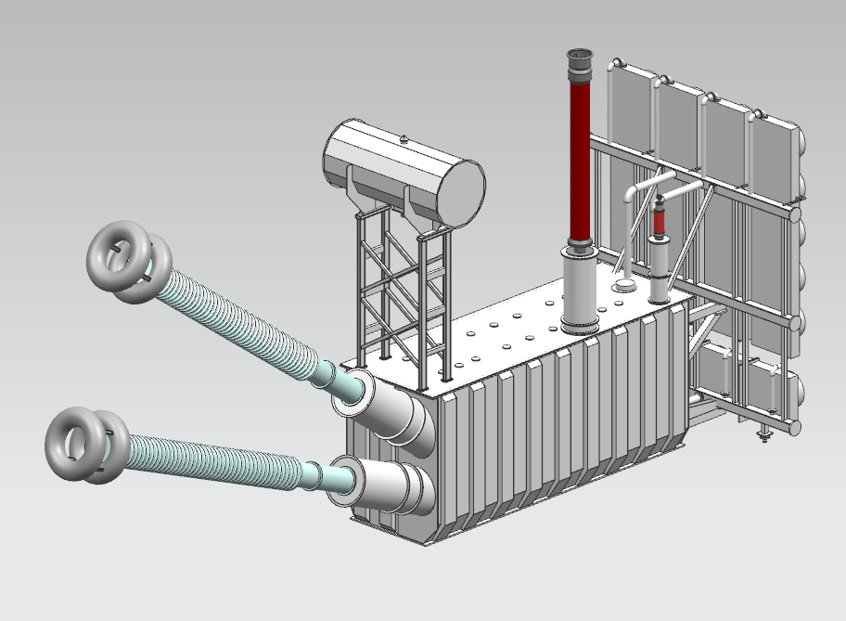
Converter Transformer Oil Conservator and Dehydrating Breather

- Transformer Breathing

Transformer is an air tight machine completely filled with insulating oil. There is no way to pass air in or out of the transformer. The atmospheric temperature is never constant and oil temperature varies with the loading of transformer. According to themodynamics law, oil expands at high temperature and contracts at low temperature. Hence an outlet is required to requied to adjust the expansion and contraction of Transformer Oil. Some expansion space is provided in the Oil Conservator placed above the Main Oil Tank. The Oil Conservator can exchange air with the atmosphere through the Dehydrating Breather and connection tube.

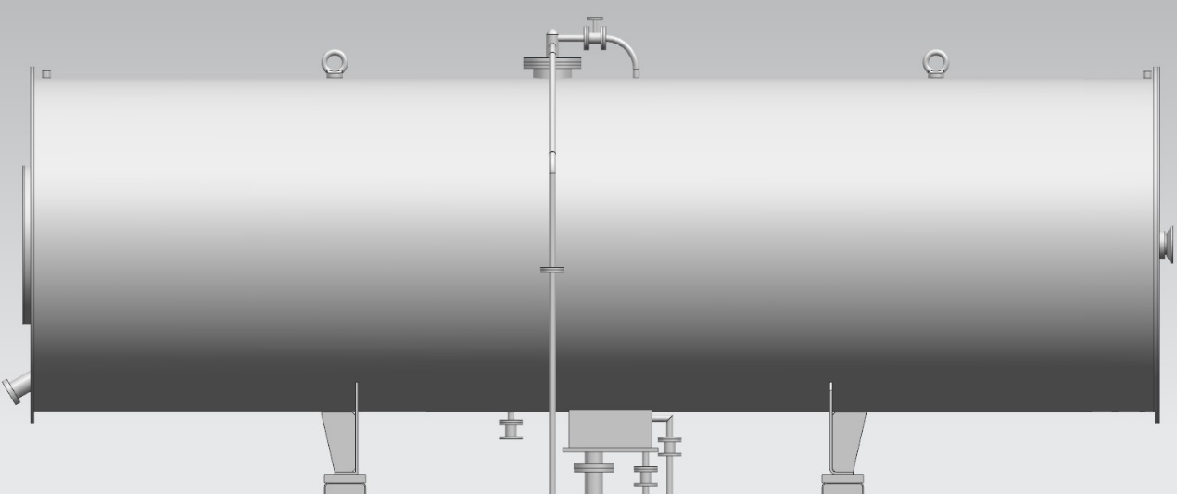
ZX5461.00534 Oil Conservator

The Transformer always inhales and exhales air during operation through silica gel breathers. When the oil temperature drops, atmospheric air enters the Oil Conservator through the breather to fill the empty space. When the Transformer Oil heats up and expands, air is pushed out through the Breather.
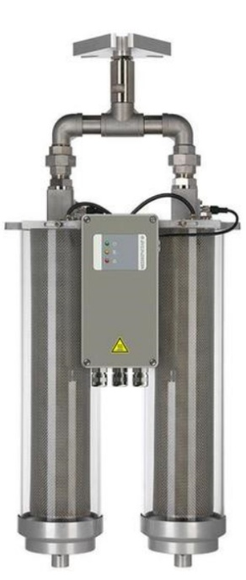
DA200D-T Dehydrating Breather

- Maintenance of Oil Conservator and Dehydrating Breather

- Oil Level Gauge: Check the upper and lower level limits according to the oil level curve nameplate. The scale and valves must not be rusty. There should be no jamming in the float ball connecting rod installation. Check that the Rotation of bevel gear is normal. Check the oil temperature and pressure during normal breathing. Check the dirt collector for oil stains. Clean the Oil Conservator, rubber bag and replace the oil. Check the seal of the rubber bag for aging or cracks. Conduct gas pressure test for the rubber bag at 0.02-0.03 MPa for 12 hours in a pool to check for leakage of gas or bubbling. If the rubber bag is damaged, it must be replaced. During installation, avoid blockage of connection pipe and joints. Hang the rubber bag on the hook and connect the outlet. Seal the rubber bag nozzle to prevent oil entry. Check safety airways, connection pipe sealing gasket and end cap for firm installation.

- Dehydrating Breather: Check the oil level of oil cup according to the scale indication and check that the oil level breathing oil cup is bubbling. Check the silica gel in the dehydrating breather for signs of moisture. If the blue color changes to 2/3 or more red, the silica gel must be replaced. Check the breather tube and oil seal cup for cracks and damage, blockage, leakage or looseness.

- Gas Relay: Check the exhaust of gas collecting box. The node signal should be normal and there should be no leakage in the metal hose connection.

- Rubber Bag: Check that the Oil level gauge operates normally. There should be no damage during rubber bag inflation inspection. Check that the true oil level is consistent with the oil level indicator.

